**Design and Implementation of a Web – Based Library Catalog and**

## Management System

A Capstone Project Proposal

Presented to the Faculty of the

College of Computer Studies and Information Technology,

Southern Leyte State University -Tomas Oppus

In Partial Fulfillment of the Requirements for the degree Bachelor of Science in Information Technology

By:

Janeth Jadman Joyce Benavente Janno Batiao Grisilda S. Abina

Mrs. Dorris S. Lintao

Adviser

May 2023

# APPROVAL SHEET

The Research/Capstone Project Study entitled **“DESIGN AND IMPLEMENTATION OF A WEB – BASED LIB”** prepared and submitted by, **JANETH JADMAN, JOYCE BENAVENTE, GRISILDA S. ABINA, JANNO**

**BATIAO** **has** been examined and is recommended for approval and acceptance.

**APPROVED** by the Committee on Oral Examination with a grade of on_____________.

**DORRIS LINTAO, MST-CS** **EFREN I. BALABA, MSIT**

Research Adviser IT Expert

**HEVIN EBARLE** **VEL INDA T. GORDUIZ, MSIT** Member Panel Chair

**ACCEPTED** and **APPROVED** in partial fulfillment of the requirements in Bachelor of Science in Information Technology.

**VELINDA T. GORDUIZ**

Department Head, BSIT

Date: _________________

# Dedication

This work is heartily and proudly dedicated to the people who serve as an inspiration. From parents and guardians to classmates and circle of friends who extended their help in the midst of problems while doing this work.

To the faculty and staff of Southern Leyte State University Tomas - Oppus Campus. Above all, to our God Almighty who showered us his blessings in our everyday lives, especially for the strength, courage, patience, wisdom, time, and guidance realization of this work.

## Acknowledgments

This paper and the research behind it would not have been possible without the exceptional support of our supervisor Mrs. Dorris Lintao who provided insight and expertise that greatly assisted the research, although they may not agree with all of the interpretations and conclusions of this paper. We also thank our Research adviser and Ms. Velinda Gorduiz for assistance with particular techniques’ and methodology and for comments that greatly improved the manuscript.

We are grateful to all of those with whom we have had the pleasure to work during this and other related projects. Nobody has been more important to us in pursuit of this project than the members of our respective families. I would like to thank our parents, whose love and guidance are with us in whatever we pursue. They are the ultimate role models.

# Executive Summary

A variety of functions are available in the library catalog management system to streamline and automate basic library procedures. It involves user management, administrative tasks, borrowing and returning, search and retrieval, and cataloging of resources. The technology increases the effectiveness of library operations by digitizing these processes to cut down on human labor, minimize errors, and improve efficiency. The creation of a centralized and well-organized catalog of library resources is one of the system's main advantages. Books, journals, multimedia, and other items can all be added, updated, and categorized by librarians with ease. Using several criteria, such as title, author, subject, or keywords, users may rapidly search for and obtain the information they want in this extensive database.

**TABLE OF CONTENTS**

**Page**

**Title Page**  i

**Approval Sheet** ii

**Dedication** iii

**Acknowledgment**  iv

**Executive Summary**  v

**Table of Contents** vi

**List of Figures**  ix

**List of Tables**  x

**List of Appendices** xi

**CHAPTER**

**1 Introduction**

Project Context 1

Purpose and Description of the Project 2

Objectives of the Project 3

Scope and Limitations of the Project 4

**2 Review of Related Literature**

Related Literature/Theoretical Background 5

Related Studies 7

Framework of the Study 10

**3 Technical Background**

Technicality of the project 11

● Context Diagram 11

● Entity-Relationship Diagram 12

● Data Flow Diagram 14

● Architectural Layout 15

Details of the technologies to be used 16

● System Components 17

● Hardware Requirements 18

● Software Requirements 19

How the project will work 21

● System Flow Chart 20

● Use Case Diagram 23

**4 Methodology**

Software Development 25

* Waterfall Methodology 25

● Requirement Analysis 26

Environment 27

o Locale 27

o Population of the Study 27

o Organizational Chart 27

o Research Instrument and 29

Data Gatherings

● Requirements Specification 31

* Operational Feasibility 32

o Fishbone 32

o Functional 33

● Decomposition Diagram

* Technical Feasibility 35

o Compatibility checking 35

other technologies

o Relevance of the technologies 36

* Schedule Feasibility 36
* Economic Feasibility 38

● System Design 39

Requirements Modeling 39

o Input 40

o Process 40

o Output 41

o Performance 41

o Control 42

o Class Diagram 42

o Activity Diagram 43

o Risk Assessment Analysis 46

● Output and User-Interface Design 47

o Forms 47

o Reports 48

● Data Design 49

o Data Dictionary Implementation 50

● System Architecture 52

o Network Model 53

o Network Topology 53

o Security 54

● Graphical User Interface Design 54

● Testing 57

o Unit Testing 57

o Integration Testing 57

o Acceptance Testing 57

● Deployment 57

* Maintenance 58

Implementation Plan 58

o Project Implementation Checklist 59

o Implementation Contingency 59

o Infrastructure/Deployment 59

**Conclusions**  62

**Recommendations**  62

**BIBLIOGRAPHY**  63

**APPENDICES** 65

**GLOSSARY** 112

**CURRICULUM VITAE**  116

# LIST OF FIGURES

**Figure Page**

1. Conceptual Framework 10
2. Context Diagram 12
3. ER Diagram 13
4. Data Flow Diagram 15
5. Architectural Layout 16
6. Admin System Flow Chart 21
7. Student System Flow Chart 22
8. Admin Use Case Diagram 23
9. Student Use Case Diagram 24
10. Waterfall Model 25
11. Organizational Chart 28
12. Fishbone Diagram 33
13. Functional Decomposition Diagram 34
14. Class Diagram 43
15. Activity Diagram of the Admin 44
16. Activity Diagram of the Students 45
17. Admin Dashboard 47
18. Students Registration form 48
19. System Architecture 52
20. Network Topology 53
21. Admin Login Form 54
22. Admin Dashboard 55
23. Website Homepage 55
24. Student Login Form 56
25. Student Homepage 56

# LIST OF TABLES

**Table Page**

1. System Components 18
2. Hardware Specifications 18
3. Software Specifications 19
4. The Respondents of the Study 27
5. Assessment Existing Process of Library Catalog Management System 30
6. Assessment of Problems Encountered with Existing System 31
7. Result of the Compatibility checking 35
8. Gantt Chart of Scheduling 36
9. Risk Assessment Analysis 46
10. Table Name – accounts 50
11. Table Name – announcement 50
12. Table Name – scholarship application 51
13. Table Name – student personal data 51
14. Table Name – user 52

**16** Performance of Newly Developed System 60

# LIST OF APPENDICES

**Appendix Page**

1. Letter of Request 65
2. Data Gathering Documentation 66
3. Map of Study Area 67
4. Questionnaire Instrument 68
5. Source Code 76
6. Screen Shots 95
7. Memorandum of Agreement 97
8. User Guide 99
9. Grammarian’s Certification 111

**CHAPTER I**

## INTRODUCTION

**Project Context**

Cataloging is a complex process and is a skill developed over time. Although cataloging is performed primarily by catalogers, ideally all librarians should understand cataloging to search the library catalog effectively and to assist library users. Its purpose is to provide and maintain content for the library catalog using content standards, encoding schemes, and controlled vocabularies, which facilitate discovery and access to library collections. In the cataloging process, library catalogers create bibliographic records that serve as surrogates for items in library collections. According to Snow, K. (2015), catalogers apply various cataloging standards that guide the creation of descriptive records, including Resource Description and Access (RDA), Library of Congress Subject Headings

(LCSH), Library of Congress Classification (LCC), or Dewey Decimal Classification (DDC).

Libraries are a great place to find information since they have a wide variety of materials available, including book, papers, journals and much more. Borrowing books is one of the key services that libraries provide. The current approach, which consists of web applications, is inefficient and not very accessible, especially for individuals who only have mobile phones. The current system is inefficient in handling all the duties a library should carry out to give its patrons better services. Users of the library might have trouble locating, recognizing, choosing, and receiving the resources they required.

Mostly, all libraries today have an online library catalog called as “Online Public

Access Catalog (OPAC)”. OPAC is an information retrieval system providing access to short bibliographic records mainly of books, journals and audiovisual materials found in a particular library. While a Web interface to an OPAC allows easy access over the Internet, a point-and-click interface and hyperlinking, it is well-known that current Web OPAC interfaces are generally still system-oriented and difficult for users to use effectively.

Problems users have with OPAC interfaces include: difficulty matching users’ search terms with those used in the database; not knowing how to broaden the search to increase the search result when too little or nothing is retrieved or how to narrow the search to reduce the search result when too much is retrieved; not knowing how to use more advanced search features such as Boolean operators, truncation, limiting keyword searches to specific fields; not knowing how to translate their information needs into a search query using the search language and search functions of the system (Poo and Khoo, 2003). Additionally, instructions and help messages are too technical for end-users to understand, and system design misleads users to commit unnecessary mistakes.

To resolve this problem, this study was proposed using web and android based

program that enables users to locate, recognized, pick out, and take possession of library goods. Users will be able to easily access material with the aid of the program without the need for librarian supervision. This web-based library catalog is to make library materials available to users with Android devices and to streamline the circulation process. Without the assistance of librarians, this program will enable users to access the resources they require. Using their Android phone, users can quickly search, recognize, choose, and receive the resources they need, which is handy and time-saving.

**Purpose and Description of the Project**

The Library Management System project is to create a user-friendly and effective system for managing a library's resources, improving access to books and other materials, and streamlining administrative procedures. This project aims to maximize the library experience for both librarians and users, increasing productivity, user pleasure, and resource efficiency. It does this by utilizing cutting-edge technologies and automation.

Purposes of library catalogue are:

* to provide all the information necessary,
* described all the item accurately both physically and intellectually in order to distinguish it from every other items
* provide a tracking system for the library's properties, and
* create a system that calculates charges automatically.

**Objective of the Project**

This main objective of this study is to design and develop a web-based library cataloging and management system that will help students and school librarian to easily access library resources. Specifically, this study aims to identify:

* 1. the problem using the manual cataloging process in SLSU -Tomas Oppus library, and
  2. assess the newly developed system in terms of:
     1. Efficiently
     2. Functionality
     3. Interface
     4. Security

**.Scope and Limitation of the Project**

A comprehensive database of all resources, including books, periodicals, multimedia, and other items, will be created as part of the library catalog. In order to make resource discovery easier, it entails gathering crucial metadata, such as title, author, subject, publication information, and unique identifiers. The library management system provides administrative tools for librarians to manage the overall library operations. It includes functionalities such as catalog maintenance, inventory management, generating reports, analyzing usage statistics, and managing fines and penalties.

Only the students and librarians at the SLSU-Tomas Oppus campus, where the system will be evaluated, are included in the study. The said institution's students and librarians will serve as a sample of data for the system. A library management system requires hardware, software, training, and continuous technical support, all of which are expensive to implement and maintain. Budget restrictions may make it difficult for libraries to create and maintain such systems.

## CHAPTER II

### REVIEW OF RELATED LITERATURE AND STUDIES

The library catalog is a fundamental component of library management systems, providing users with access to information about the library's collection. Limited time and staffing School librarians frequently have many duties to do, but little time to do so. They might have a hard time juggling administrative duties, collection creation, information literacy instruction, and giving each student the attention, they need. Encourage user evaluation and input on the catalog and administration system for the library. Assess customer happiness frequently, collect suggestions for enhancements, and make adjustments as necessary. Engage stakeholders, including library employees, patrons, and users, to assess the system's performance in achieving the library's objectives and make adjustments as necessary.

Library software is an important tool in today’s changing environment of libraries. Now a day many libraries are using library management software to manage library in a computerized way. Today, KOHA is one of the most advanced open-source Integrated library system in use today by hundreds of libraries worldwide (Kumar, 2013). KOHA is very useful library management system in providing various library services to users including circulation of library material, cataloguing, new arrival etc. That found proprietary software expansive and lacking some needed features. The full features KOHA was developed initially in New Zealand by Katipo Communications limited and first developed in January 2000 for Horowwhenua Library trust. KOHA is designed to work with a minimum of hardware resources. It runs on the Linux Operating system in conjunction with the apache Web Server, uses the popular MySql open-source database management system and is written in Pearl. (Tella, Adeyinka & Others). KOHA is an open source ILMS which can keep track of library operations such as items, billing, tracking various items owned by library such as books, journals, newspapers etc. (Vera, 2015). KOHA is an open software Library Integrated Management System (LIMS) and is used worldwide by public, school, and academic libraries, which its developments was steered by a growing community of libraries and users collaborating to achieve their technological goal (Sobalaje Adewale Joel & others).

**LIBRARY BORROWING AND INVENTORY SYSTEM**

Library Borrowing is a process where a library member can borrow a book, store ISBN, user ID, date issued, date due to return, date returned (https://sites.google.com/site/calculatorssvc/project-definition). On the other hand, inventory refer to the complete list or record of all the materials or resources available within a library's collection. It includes books, periodicals, multimedia items, reference materials, and any other items that are part of the library's holdings. An inventory serves as a comprehensive catalog of the library's resources, allowing staff and patrons to locate and access specific materials.

The inventory process will be dependent on your library management system. For example, TALIS Network libraries have specific inventory instructions on the TALIS Support Website. Manual libraries need to check the items on the shelves against a shelf list. In any inventory you need to work systematically within a collection: section by

section, shelf by shelf. This will ensure items are not missed (https://libraries.tas.gov.au/school-library-guidelines). Espeña, C. J. (2020) in their study entitled automated library management system for Llano High School to manage and monitor the books in the library. The library management system is designed to help the admin maintain and organize the library. Using this system, the librarian can easily monitor the borrowed/returned books. The researchers used the systems development life cycle process to complete this project. In the planning stage, the researchers planned to make a system for Llano High School. In the analysis stage, the researchers analyzed the idea and data that the client gave us. In the design stage, the researchers designed the system using ERD, flowchart, and use case. In the development stage, the researchers built the system by using coding.

**MAKING A LIBRARY CATALOGUE PART OF THE SEMANTIC WEB**

Library catalogue contain an enormous amount of structured, high-quality data; however, this data is generally not made available to semantic web applications. In this paper, we describe the tools and techniques used to make the Swedish Union Catalogue (LIBRIS) part of the Semantic Web and Linked Data. The focus is on links to and between resources and the mechanisms used to make data available, rather than a perfect description of the individual resources. We also present a method of creating links between records of the same work.

Although there are a number of ontologies available to describe bibliographic data, the data contained in library systems are not generally available. The access mechanisms described in Linked Data need to be implemented for libraries to truly be “part of the semantic web”. SPARQL shows real promise when it comes to mining bibliographic data for information due to its linked nature. Planned next steps include using SPARQL for automatic creation of work records, implementing a richer description of bibliographic and authority records, and loading more external data into the triple store (Malmsten, M. (2008).

**Conceptual Framework**

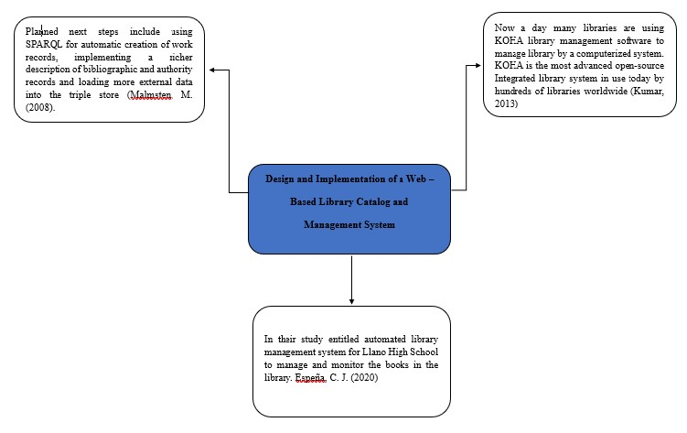

**Figure 1: Conceptual Framework of the Study**

Figure.1 presents the conceptual framework of this project, This conceptual framework shows the important feature of this system it will also show following related studies of this system. It provides a structure for conceptualizing the various aspects of library management and helps guide decision-making and strategic planning. The next researchers can gain a comprehensive understanding of the existing literature, identify knowledge gaps, propose future research directions, and provide practical insights for library management professionals.

**CHAPTER III**

### TECHNICAL BACKGROUND

**Technicality of the Project**

**Context Diagram (CD)**

Context diagrams display how a system interacts with other actors (external factors) that it is intended to communicate with. Diagrams showing the system context might be useful in understanding the setting in which the system will operate. The *context diagram* of a vision document is a simple diagram that shows the source systems contributing data to a DW/BI system, as well as the major user constituents and downstream information systems that is supports. This simple diagram only takes a few minutes to draw once the project architect has completed all the research and the hard thinking that it represents. This diagram’s simplicity makes it perfect for agile requirements management. With such a specific purpose and simple grammar, existing versions of this artifact prove to be very easy to update as business conditions evolve and as design insights occur during the life of the project.

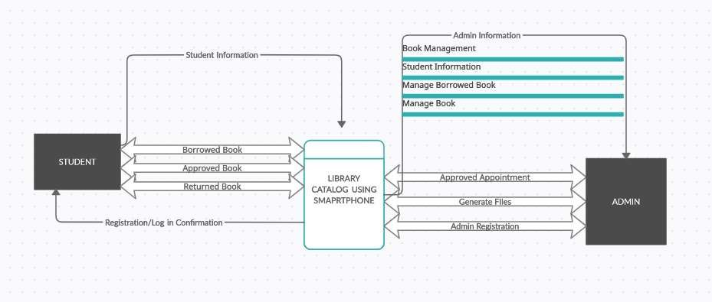

### Figure 2. Context Diagram

In the Library Catalog System there are two entities: students and admin both need to register and log in. Only registered users can access the system, borrow books and acquire the said information. The admins can register also, monitor the books borrowed and returned, updates the approved the book borrowers. The system will also display the list of the students whom borrowed the books and scheduled time they check out the book.

**Entity - Relationship Diagram**

An entity relationship diagram (ERD), also known as an entity relationship model is a graphical representation that depicts relationships among people, objects, places, concepts or events within an information technology system. An ERD uses data modeling techniques that can help define business processes and serve as the foundation for a relational database.

*Biscobing, J. (2019, September 11).* The Library Catalog System is modeled in this ER (Entity Relationship) Diagram, which displays all the visual tools of database tables and the relationships between students, administration, and staff as well as the books that are being monitored and the schedule of resources that are available. The linkages between structured data sets of book information were defined using structured data.

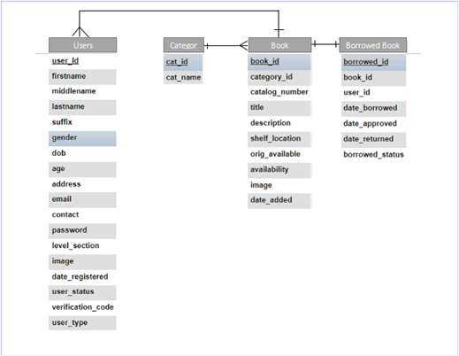

### Figure 3. Entity - Relationship Diagram

In figure 3 above, librarian(user): Represents the library staff responsible for managing the library system. A librarian has a unique staff ID, a name, and an email address. Member(user): Represents library members who borrow books from the library. Book: Represents a book in the library's collection. Each book has a book ID, a title, an author, and publication information.

**Data Flow Diagram**

Data flow diagrams visually represent systems and processes that would be hard to describe in just words. You can use these diagrams to map out an existing system and make it better or to plan out a new system for implementation. Visualizing each element makes it easy to identify inefficiencies and produce the best possible system  *Data Flow Diagram*

*Examples Symbols, Types, and Tips. (2019, October 25). Lucidchart.*

*https://www.lucidchart.com/blog/data-flow-diagram-tutorial*

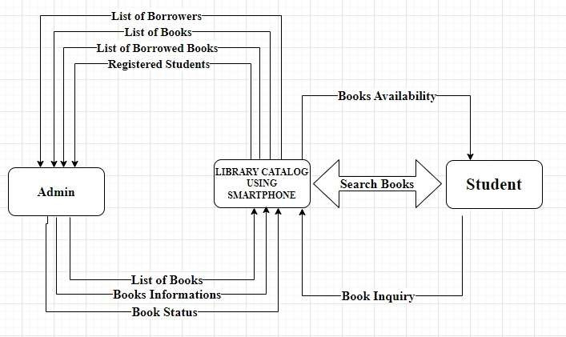

### Figure 4. Data Flow

The data flow diagram for the Library Catalog System is frequently used as a preliminary step to create an overview of the Library Catalog System without going into great detail. The Library Catalog System includes two sorts of users: students and administrators. From student information to appointment records, the system will handle it all. The administrator will handle the student’s information and the book information where the book at and whom will be the borrower will be.

**Architectural Layout**

Figure 5 depicts the overall system architecture. Students can use a web browser to access appointment information via the Internet. The middle tier displays web app services such as registration and login, which are then directed to admin and student information, manage books, and an email generator. The results from the application server will be converted into HTML format through the web server. The portal server handles user login and registration requests. The database contains detailed information about each requested book, a list of books, login information for students and instructors, and other information.

**Figure 5. Architectural Layout**

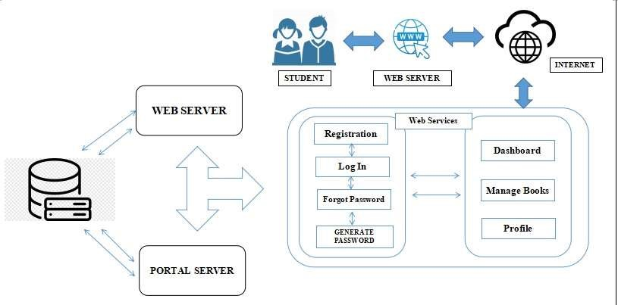

**Details of the technologies to be used:**

**System Component Diagram**

The purpose of a component diagram is to show the relationship between different components in a system. For the purpose of UML 2.0, the term "component" refers to a module of classes that represent independent systems or subsystems with the ability to interface with the rest of the system. A component diagram in UML gives a bird’s-eye view of your software system. Understanding the exact service behavior that each piece of your software provides will make you a better developer. Component diagrams can describe software systems that are implemented in any programming language or style. Component Diagram Tutorial. (n.d.). Lucidchart. https://www.lucidchart.com/pages/umlcomponent-diagram#:~)

Users can access the proponents' web-based program with any digital platform. The Web-based Library Catalog is an online library catalog for students who wish to visit and borrow a book for easy and convenient access without using the manual process. These are the technical terms that are being used in creating our project: Sublime Text 3 - Text Editor,

Database - XAMPP.

|  |  |  |
| --- | --- | --- |
| **Hardware Name** | **Description** | **Purpose and Function** |
| Operating System | not older than Windows 10 | The operating system (OS) manages all of the software and hardware on the computer. It performs basic tasks such as file, memory and process management, handling input and output, and controlling peripheral devices such as disk drives and printers. |
| Mobile or  Smartphone | android or ios | For user purposes to access the application system. |
| Computer Speed  Processor |  | The processor, also known as the CPU, provides the instructions and processing power the computer needs to do its work. The more powerful and updated your processor, the faster your computer can complete its tasks. By getting a more powerful processor, you can help your computer think and work faster. |
| Laptop | core, intel i3, i5, i7 | Most laptops are designed to have all of the functionality of a desktop computer, which means they can generally run the same software and open the same types of files. |

### Table 1. Hardware Components

Hardware components may be used to support its operations. The table above are some common hardware components that we use of creating a library management system setup.

|  |  |  |
| --- | --- | --- |
| **Software Name** | **Description** | **Purpose and Function** |
| Web browser |  | It retrieves information from other parts of the web and displays it on your desktop or mobile device. |
| Xampp version  3.3.0 | version 3.3.0 | XAMPP is simply a local host or server that is used to test clients for websites before publishing them to a remote web server. |
| **Sublime Text 3** | Sublime Text 3 (ST3) | Sublime Text is a popular text editor that is widely used by developers and programmers for coding and text editing purposes. It is known for its simplicity, speed, and extensive customization options. |
| PHP, Javascript,  CSS, HTML 5 |  | Each has a distinct function, and they all work together to bring you stunning  websites with fresh information. |

### Table 2. Software Components

This section describes the hardware and software requirements for the system's effective and efficient operation. The hardware requirements used by the developers to create the Library Catalog are detailed in Table 1 and Table 2. Each hardware name was described and its purpose and function were identified.

**How the project will work**

A flowchart is a visual representation of a process or system that uses various shapes, symbols, and arrows to illustrate the sequence of steps or actions involved. It provides a clear and concise overview of the logical flow and decision points within a process. Flowcharts are widely used in fields such as software development, project management, manufacturing, and business processes. A flowchart is a diagram that depicts a process, system or computer algorithm. They are widely used in multiple fields to document, study, plan, improve and communicate often complex processes in clear, easyto-understand diagrams. Flowcharts, sometimes spelled as flow charts, use rectangles, ovals, diamonds and potentially numerous other shapes to define the type of step, along with connecting arrows to define flow and sequence. They can range from simple, handdrawn charts to comprehensive computer-drawn diagrams depicting multiple steps and routes.

*What is a Flowchart. (n.d.). Lucidchart. https://www.lucidchart.com/pages/what-is-aflowchart-tutorial*

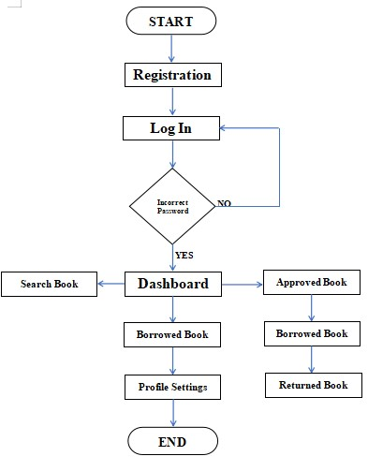

### Figure 6. student/user flowchart

**Figure 6 above is** the student/user flowchart that shows the flow of data. It starts with making an account before you can login to the system. Once you can login, you will be directed to the homepage/dashboard that contains approved books, borrowed books, and returned books. In the same dashboard it also contains your borrowed book and your profile settings.

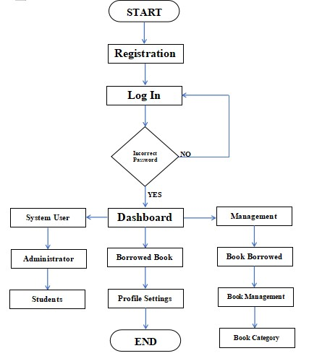

**Figure. 7 user admin flowchart**

Figure 7 above is the admin flowchart. It starts with admin log in, Once the admin log in his/ her account you will be directly to the dashboard that contains management, system user, and profile settings.

**Use Case Diagram**

Use-case diagrams describe the high-level functions and scope of a system. These diagrams also identify the interactions between the system and its actors. The use cases and actors in use-case diagrams describe what the system does and how the actors use it, but not how the system operates internally.

*IBM Documentation. (n.d.-b). https://www.ibm.com/docs/en/rational-softarch/9.6.1?topic=diagrams*

The interactions between the components of the Library Catalog System are graphically shown in this use case diagram in figure 8 below. It reflects the process of identifying, outlining, and organizing the system requirements for the Library Catalog System. Administrators and users (students), who carry out various use cases, are the principal actors in LCS. The user's interaction with the system that illustrates the relationship between the administrator and users was represented by the developer using a use-case diagram.

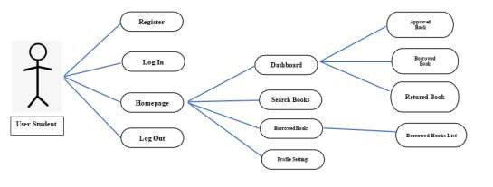

**Figure 8.** User Student Use-Case Diagram

Figure 8 represents the User Student use case. The User Student uses the system to display the dashboard they can search books they could see what books are pending and they can edit their profile settings.

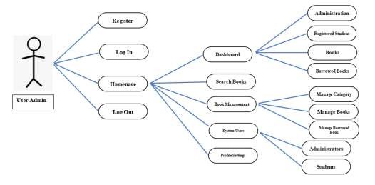

### Figure 9. User admin Use-Case Diagram

Figure 9 represents the User admin use case. The User Admin uses the system to display the dashboard they can manage the books, the admin will be notified who registered on the system and borrowed and returned the book. The admin can also Manage the books, and categorize them.

**Chapter 4**

### METHODOLOGY

**Software Development**

It is a methodology for systematically organizing the best ways to develop systems efficiently. It includes, for example, descriptions of work to be performed at each stage of the development process and drafted documents. Multiple methodologies—which differ according to viewpoint—are available. In terms of the development process, some example methodologies are "water-fall development," "spiral development," and "agile software development." And in terms of the design approach, some example methodologies are the process-oriented approach (POA), the data-oriented approach

(DOA), the object-oriented approach (OOA), and the service-oriented approach (SOA).

Hitachi, Ltd. (n.d.). *Hitachi Global*. https://www.hitachi.com/

The development of the Student Appointment and Scheduling System used the waterfall model. The waterfall model provides a sequential approach to software life phases starting from requirements analysis, system design, testing, deployment, and maintenance.

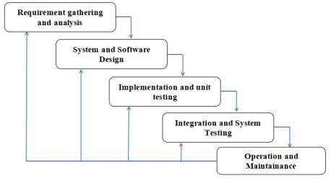

### Figure 10. SDLC - Waterfall Model

The waterfall model is a classical model used in system development life cycle to create a system with a linear and sequential approach. It is termed as waterfall because the model develops systematically from one phase to another in a downward fashion. This model is divided into different phases and the output of one phase is used as the input of the next phase. Every phase has to be completed before the next phase starts and there is no overlapping of the phases.

**Requirement Analysis**

The requirements to create the software are hardware, software, and

development tools. Hardware materials required for the web-based are a 64-bit i3 processor with at least 16GB RAM, 500 GB Hard Disk Drive or 128GB Solid State Drive, and Windows 10 version. The development tools needed are HTML, CSS for markup language and PHP, JavaScript for backend coding stands as a programming language; Bootstrap for the design of the system; and Adobe Photoshop for the logo making.

**Environment**

**Locale**

This study was conducted at Southern Leyte State University - Tomas

Oppus Campus Library (SLSU-T.O). The SLSU-T.O is located at San Isidro, Tomas Oppus, Southern Leyte. Southern Leyte began as a province with sixteen (16) municipalities. The university offered four bachelor courses, BS Elementary Education,

BS Secondary Education, BS Business Administration, and lastly, BS Information Technology.

**Population of the Study**

The respondents of this study include the college students of SLSU-T.O campus who have been in college for at least one year and The library staff. The survey is administered to the student and library staff participants through hands on.

|  |  |
| --- | --- |
| **Respondents** | **Frequency** |
| **Students** | 10 |
| **Librarian** | 2 |
| **Total** | 12 |

**Table 3:** Frequency of Respondent

The participants in this study are the 10 students and 2 librarians of SLSU TO who were chosen by the researcher respondent. There are total of 12 respondents.

**ORGANIZATIONAL CHART**

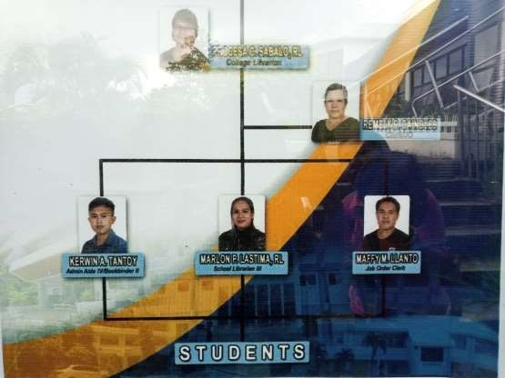

### Figure 11. ORGANIZATIONAL CHART

**Research Instruments and Data Gathering Procedure**

To gather data that would aid in understanding the Design and Implementation of a Web–Based Library Catalog and Management System, the researchers of this study first requested permission from the respondents to conduct a survey. The researchers construct two sets of questionnaires to collect the relevant data. The first set of the questionnaire lists the issues with the current system and the things that should be added to improve it. Following the approval of the project's research tools, the researcher wrote a letter of request to the SLSU-TO campus asking for authorization to carry out the study. The responders, particularly the kids and teachers/staff, were briefed on the questions before to the administration and given instructions on how to accurately respond to them.

Following a brief explanation of the study's objectives to the chosen respondents, the researchers verified that each respondent met their predetermined criteria. Utilizing a survey questionnaire, the researchers gathered the participants' names, positions, student status, year level, and courses. The survey was then completed by the participants, and the results were verified, added up, interpreted, and evaluated.

**ASSESSMENT OF SLSU-TO STUDENTS AND INSTRUCTORS/STAFF**

The content of this section includes the presentation, analysis, and interpretation of data that has been collected during the data gathering from our respondents – 10% of the total population of SLSU TO.

To ascertain the issues the manual method runs into, the researchers distribute the first set of questionnaires to the respondents—students and the campus librarian of SLSUTO. Additionally, features that should be included in the Design and Implementation of a Web-Based Library Catalog and Management System are attached to the first batch of questionnaires, allowing the researchers to draw conclusions about which features respondents highly value based on the system's proposed functions. Following the simulation of the Design and Implementation of a Web-Based Library Catalog and Management System at the SLSU-TO campus, the same respondents received the second round of questionnaires. Its purpose is to assess the Library Catalog and Management System's effectiveness, relevance, efficiency, responsiveness, design, and data processing.

**Data Analysis Procedure**

The data gathered from the junior students and librarian staff of the SLSU-TO campus were processed, analyzed, interpreted, and treated using a weighted mean.

**Assessment of Existing Process in Web Based Library Catalog and Management System**

Table 4 below shows that 100 percent of the respondents answered that the existing process was used manually. Therefore, SLSU-Tomas Oppus is still using the manual process to monitor the student's records.

|  |  |  |
| --- | --- | --- |
| **Existing System** | **Frequency** | **Percentage (%)** |
| Automated | 13 | 100% |
| Manual | 0 | 0% |
| **Total** | 13 | 100% |

**Table 4.** Data Analysis Procedure

**Assessment of the Problems Encountered with Design and Implementation of a Web – Based Library Catalog and Management System**

Table 5 presents the result of the assessment of the problem encountered using automated student record monitoring. 10 respondents rated the questionnaire on a scale of 4-1 and were interpreted based on the weighted mean. The majority of the respondents strongly agreed that making an automated manual costs much time and hassle for the students and instructors.

The result of the gathered data further allowed the researchers to realize the seriousness of the given problems in the existing manual system which results in the researchers to be persistently and tenaciously pursuing to create the system.

|  |  |  |  |  |  |  |
| --- | --- | --- | --- | --- | --- | --- |
| **PROBLEMS**  **ENCOUNTERED** | **Response (n=10)** | | |  | **Weighted Mean** | **Interpretations** |
| **4** | **3** | **2** | **1** |
| Limited availability they need to visit the library to see if the specific book is  available or not | 5 | 4 |  | 1 | 3.3% | Strongly Agree |
| Unorganized returns: If books are not properly organized upon return, it can create confusion for both students and library staff. | 7 | 3 |  |  | 3.7% | Strongly Agree |
| It Consumes too much time. | 8 | 2 |  |  | 3.8% | Strongly Agree |
| **AVERAGE** | | | |  | **3.6%** | **Strongly Agree** |

**Table 5.** Problems Encountered by Respondents

**Requirements Specification**

System requirements can be called the expanded version of the user requirements. System requirements act as the commencement point for any new system design. These requirements are a detailed description of the user requirements the system must satisfy. A requirements specification is a document that outlines the specific needs of a project or system. The requirements specification is important because it serves as the foundation for

all future work on the project. Solutions, V., & Jain, A. (2023)

https://visuresolutions.com/blog/requirementsspecification/#:~:text=A%20requirements%20specification%20is%20a,future%20work% 20on%20the%20project.

**OPERATIONAL FEASIBILITY**

Operational feasibility refers to how the project developers developed the system development concept. It also responds to the technical methods of the project developers in continuing to perform considered actions in the general process that the project developers want to communicate and convey to the users who will use their system. This part is important, which shows the identities of each process that the project developers want to develop so that it can continue to provide the services expected in how it is necessary to solve the problems that depend on how it will be given clarity and solution of project developers.

**FISHBONE DIAGRAM**

Figure #12. The fishbone diagram refers to the different types of problems that must be answered by project developers. This diagram shows the different types and categories of problems that are said. Each of these problems refers to the current state of the system or the practice of users who use this process. It is said that one of the most effective methods for project developers to have an idea of the processes they want to develop is to have extensive analyzes and consider the problems that occur in situations where it is necessary to give competent answers.

**Figure 12. Fishbone Diagram**

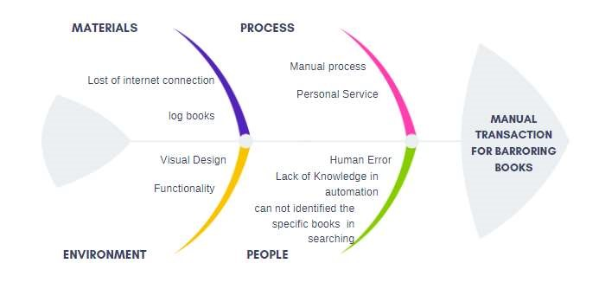

**FUNCTIONAL DECOMPOSITION DIAGRAM**

The functional decomposition diagram refers to how the system provides services to each type of users who use it.

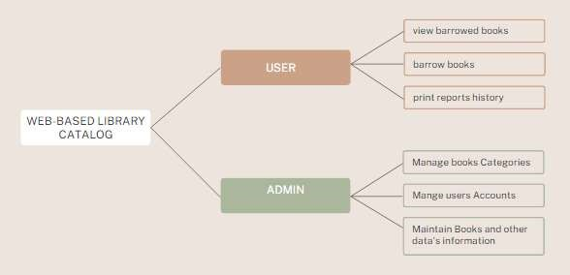

### FIGURE #13. FUNCTIONAL DECOMPOSITION DIAGRAM

The figure above will show the capabilities of each user using the system developed by the project developers. The model also shows each summary ability of the users in what are the features covered that they do to follow the correct process of the system. Perhaps the most effective method and process of how to make it easier to understand the current goals of the project is to provide its basic needs with the method of how it can be safely

carried out.

**TECHNICAL FEASIBILITY**

The technical feasibility, on the other hand, refers to what characteristics are required by the system to enable each of the features that this system has. It responds to events that can enable the system developed by project developers. It can be said that the presence of project developers is important in these types of events because it refers to how problems that may arise in the future can be answered, and this is one of the most effective measures for these states.

**COMPATIBILITY CHECKING OTHER TECHNOLOGIES**

Compatibility checking other technologies shows the importance of the project's strong goal to work on any technological platform. In that way, it will continue to fulfill the guidelines it wants to fulfill for the users who will use the system that is being developed. Remember that the existence of a system that will facilitate the tasks of each user will greatly help the continuous growth of technology, not only in technical aspects but in aspects focused on the welfare of each user who will use a system composed of project developers.

**RELEVANCE OF THE TECHNOLOGIES**

The relevance of the technologies is shown in the table which is this system shows the fields where the system can be used. This includes operating systems or the usual browser tools to interact with said system.

|  |  |  |  |
| --- | --- | --- | --- |
|  | **Computer /**  **Laptop** | **Operating System** | **Web Browser** |
| **System** |  | **Windows 10** | **Chrome** |
| **Design and Implementation of a Web – Based Library**  **Catalog and**  **Management System** |  |  |  |

### Table 6. Relevance of the Technologies

**SCHEDULE FEASIBILITY**

The scheduling feasibility shows the total time it took the project developers to complete the project they are seeking to complete. Because of this table, readers have the ability to gather details and ideas which they can use as a basis for the continued development of their project. This table also shows the importance of each member of the group. of project developers to know where they are assigned to do their duties.

|  |  |  |  |  |  |  |  |  |  |
| --- | --- | --- | --- | --- | --- | --- | --- | --- | --- |
| TASK | ASSIGNED | PROGRESS | START |  |  |  |  |  | END |
|  |  |  | MAY 2022 | DEC | JAN  2023 | FEB | MAR | APR | MAY |
| System Design | Programmer | 100% |  |  |  |  |  |  |  |
| System  Implementation | Programmer | 100% |  |  |  |  |  |  |  |
| Testing | Programmer | 100% |  |  |  |  |  |  |  |
| CHAPTER 1 | Technical  Writer | 100% |  |  |  |  |  |  |  |
| CHAPTER 2 | Technical  Writer | 100% |  |  |  |  |  |  |  |
| CHAPTER 3 | Technical  Writer | 100% |  |  |  |  |  |  |  |
| CHAPTER 4 | Technical  Writer | 100% |  |  |  |  |  |  |  |

**Table 7. SCHEDULE FEASIBILITY**

**ECONOMIC FEASIBILITY**

**COST AND BENEFIT ANALYSIS.**

This table shows the total cost required to develop the system made by the project developers. Each item shows the events that made it the total cost of the project developers. It is said that it is important to have some kind of documentation of these because attention will be paid to the states that can be a basis for project developers for how much their total cost has been.

|  |  |
| --- | --- |
| **Expenses** | **Amount** |
| Internet Expenses | 3,000 |
| Paper and Photocopy Expenses | 5,000 |
| Transportation | 10,000 |
| Miscellaneous Expenses | 20,000 |
| **Total** | 38,000 |

### TABLE #8 COST AND BENEFITS ANALYSIS

**Cost Recovery Scheme**

The cost recovery scheme, on the other hand, refers to the information that gives importance to the development of the system. This includes the placement of appropriate details in each of the fields contained in the table seen below. Each of these details is displayed within the considered month. This is also a good method of recording to show the important details about the total cost that is also referred to in the previous table.

|  |  |  |  |  |  |  |
| --- | --- | --- | --- | --- | --- | --- |
| **Expenses** | **AUG** | **SEPT** | **OCT** | **NOV** | **DEC** | **TOTAL** |
| Internet Expenses | 600 | 600 | 700 | 600 | 500 | 3,000 |
| Paper and Photocopy Expenses | 300 | 300 | 300 | 300 | 300 | 1,500 |
| Transportation | 1,500 | 500 | 500 | 400 | 600 | 3,500 |
| Miscellaneous Expenses | 2,000 | 600 | 1,000 | 500 | 500 | 4,600 |

**Table 9:** Cost Recovery Scheme

**SYSTEM DESIGN**

The system design refers to how the project developers gave the event to make it more meaningful. To sum up, system design explains what the project developers need to clarify and pay attention to in the system they are making. It is only necessary to have the skill of recording the most effective method required to solve the problems that can give the project developers an obstacle, and this also includes the implementation of the solutions that have gone through a thorough study carried out by the project developers without tired of looking for a solution to what method would give them the most efficient answer for all system requirements.

**REQUIREMENTS MODELING**

Requirements modeling refers to the identification of each method of the system, how it works, and how it can provide a valuable result for project developers.

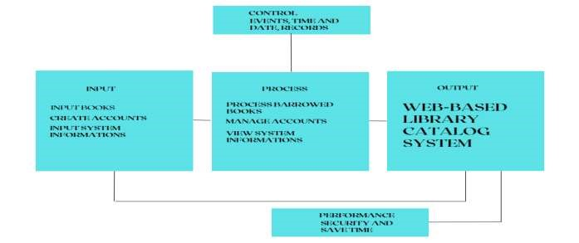

### Figure 14. REQUIREMENTS MODELING

The Figure above which is figure 14 This figure shows input, process, and output including control and performance. Above is the figure that is said also to include

explanations of each phase that this system has.

**INPUT**

In the input phase, important information is placed which is required by the system to give it actions. It is also necessary for this phase to give the system the necessary details so that it can be processed successfully.

**PROCESS**

In the process phase, the methods or capabilities of the system can be seen in which it can freely process each of the inputs given to it. it is also necessary that the system has a progressive and effective process so that it can provide the result that is more necessary to be the basis of the system.

**OUTPUT**

The output phase refers to the system itself developed by the project developers titled

Web-based Library Catalog System

**PERFORMANCE**

This performance phase refers to how the system process becomes useful. Where it can provide an accurate result that will be even more beneficial for users.

**CONTROL**

The control phase refers to how the system has unique capabilities which are more and more necessary for the continuation of the system process.

**CLASS DIAGRAM**

According to Wikipedia (2023) In software engineering, a class diagram in the Unified Modeling Language (UML) is a type of static structure diagram that describes the structure of a system by showing the system's classes, attributes, operations (or methods), and the relationships among objects.

The class diagram is the main building block of object-oriented modeling. It is used for general conceptual modeling of the structure of the application, and for detailed modeling, translating the models into programming code. Class diagrams can also be used for data modeling. The classes in a class diagram represent both the main elements, interactions in the application, and the classes to be programmed.

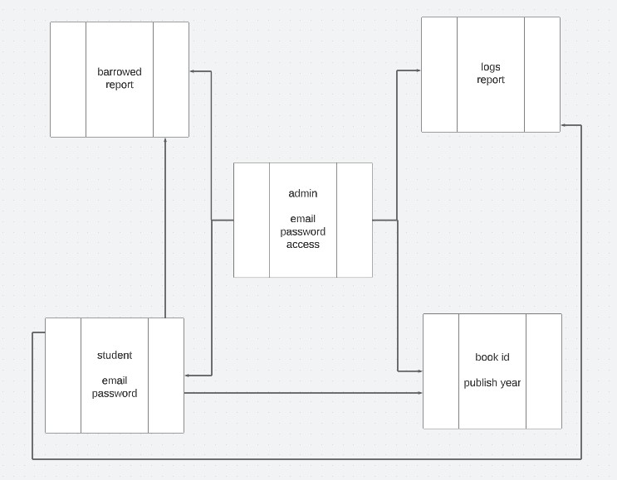

Figure 15. Class Diagram

**ACTIVITY DIAGRAM**

According to Mind Manager (2022), An activity diagram is a type of Unified Modeling Language (UML) flowchart that shows the flow from one activity to another in a system or process. It's used to describe the different dynamic aspects of a system and is referred to as a 'behavior diagram' because it describes what should happen in the modeled system.

Even very complex systems can be visualized by activity diagrams. As a result, activity diagrams are often used in business process modeling or to describe the steps of a use case diagram within organizations. They show the individual steps in an activity and the order in which they are presented. They can also show the flow of data between activities. Activity diagrams show the process from the start (the initial state) to the end (the final state). Each activity diagram includes an action, decision node, control flows, start node, and end node.

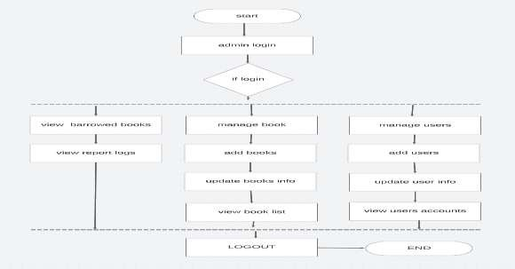

### Figure 16 Admin Access

**Figure 17 Student Access**

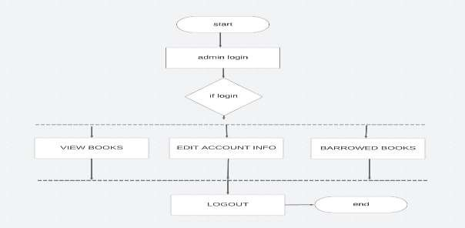

**RISK ASSESSMENTS ANALYSIS**

Risk assessments refer to matters of how the system has possible problems. It is also characteristic of explaining what are the causes of the known problem, and in that way, the risk assessments also respond to what method the project developers need to use in the possible problem that occurs and gives the system difficulty to solve it safely. Emphasis is also placed on unique problems in accordance with how they affect the overall process of the system.

|  |  |  |
| --- | --- | --- |
| RISK | POSSIBLE CONFLICT | MITIGATION METHOD |
| human error | not returning the book | Check the user account and find the borrowed book from users |
| Books management | Failed to recover a borrowed books | Keep the current user screening important to avoid unexpected book  losses |

### Table 12. RISK ASSESSMENTS ANALYSIS

**Output and User Interface Design**

It is a two-way exchange. The system receives input data and instructions (what users wish to do) in a variety of ways. Responses from the system include outputs, error messages, feedback, warnings, help functions, etc. The interface also describes how users move about the program.

**FORMS:** Admin

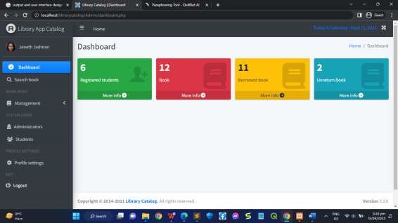

Figure 18. Admin dashboard

Admin Dashboard. This is where the admin can view the total of Registered Students, total of books, total of how many books have been borrowed and the total of how many unreturned books.

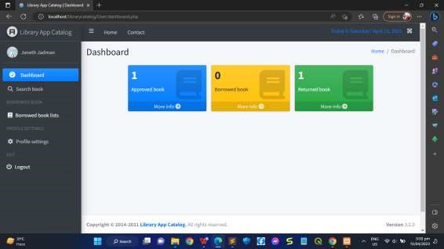

Figure 19. Student Dashboard

Student Dashboard. This is where the students view their approved books, borrowed book, and returned books.

**DATA DESIGN**

The data design refers to the identification of each data table required by the system to provide service to the users who will use it. Data design also contains different types of variable declarations that process each data that enters the system database. It is said that having enough records of the most important events for this matter provides the sufficient ability for project developers to deliver an organized data collection necessary for users to enjoy the system developed even more. and the project developers worked hard to finish.

**DATA DICTIONARY**

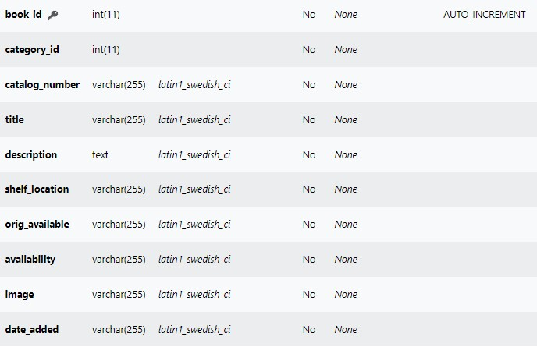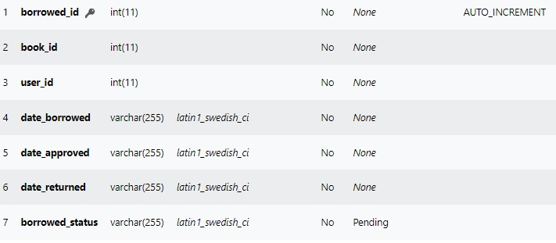

**SYSTEM ARCHITECTURE**

According to Third Stage Consulting Group LLC (2022), The system architecture is a key to an effective digital transformation, especially in today's day and age with the plethora of technologies an organization needs to succeed. With a variety of supporting technologies, system architecture is becoming more important than ever.

The system architecture has always been a critical aspect of any digital transformation. If you think about all the different technologies that organizations need to thrive. From financial systems, warehouse management systems, supply chains, human capital management, smart factories, the Internet of things, Industry 4.0, robotics on the shop floor, and many more. There are a lot of happenings within organizations that require different technologies and need to come together to provide common business processes and visibility into what's going on throughout the operations.

**NETWORK MODEL**

The network model refers to how each role, features, software, and hardware configuration that the system has made by the project developers have a relationship. It highlights the most important parts where it gives clarity to every reader in the easiest way how to understand it more fully. The network model aims to provide the overall capabilities of the system showing the different levels of connectivity required for its unique process.

**NETWORK TOPOLOGY**

The network topology refers to how the process flow of the system works. It shows the importance of each connection found below. It is important to have this type of figure which shows the importance of the total level of capability of the system developed by the project developers. Perhaps there are things and goals that need to be considered at each level or aspect of the development phase.

**GRAPHICAL USER INTERFACE DESIGN**

The (GUI) or Graphical User Interface Design can be said to be one of the most important parts of the development necessary consider the project developers because it responds to how it will be more pleasant for the eyes of the users who use the system. It is said that the presence of a clean presentation system can provide satisfaction for users. As a project developer, it is necessary to pay attention or value to this type of matter because it can provide even more satisfaction for the project developers if they know that the GUI presentation of their system is liked by the users who will use it. It is said that one of the big bases of system presentation is the responsiveness of the user interface because it usually makes the process easier in how users will use it.

**FORMS**

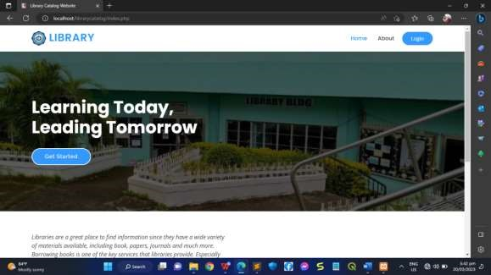

### Figure 20. Homepage

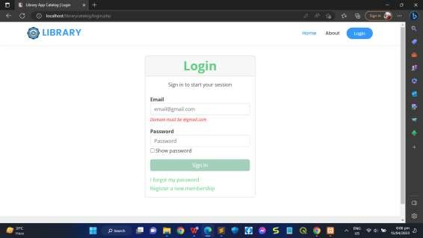

### Figure 21. Admin Log in



### Figure 22 Student Log in

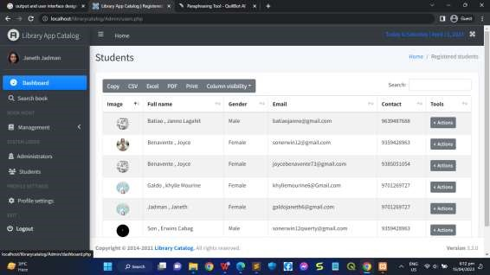**Figure 23. Admin Student List**

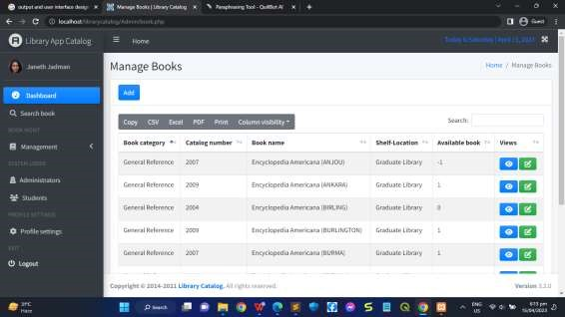

### Figure 24. Admin Book List

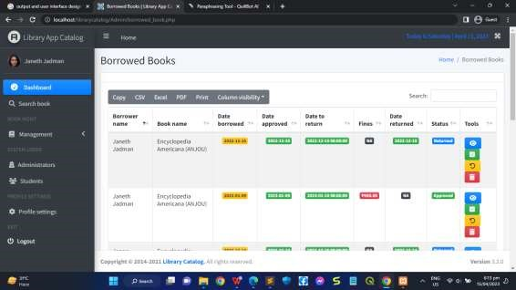**Figure 25. Admin Borrowed Books List**

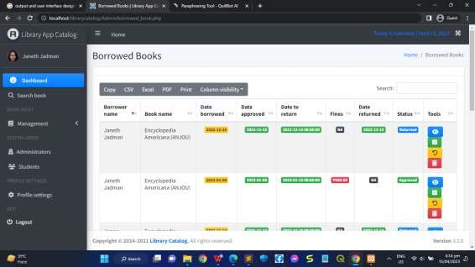

### Figure 26 .Admin Unreturned Books Lists

**FORMS: STUDENTS**

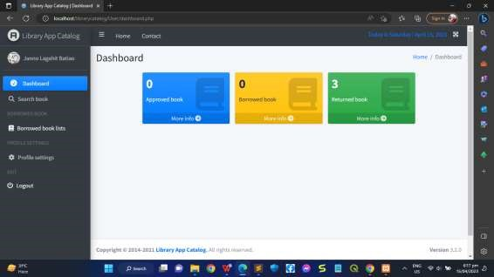

**TESTING**

The Testing phase is one of the most important parts of the development because in this phase the project developers will know and prove if the project, they created will be a beneficial system where it will really help the users to provide enough of that service. Testing goes through several stages where each stage of testing has the ability to provide some unique results that are necessary to better understand what problems the system may face in the future if in case it comes to the scene that can be used by its unique users.

|  |  |  |  |  |
| --- | --- | --- | --- | --- |
| Type of Testing | Action Plan | Duration | Result | Action Taken |
| Unit Testing | Analysis of each unit  required and  included in the  system to  determine the necessary repairs to each of these units. | March 2023 | It has been proven that  there are units in the system that require attention in  order to provide a  competent solution. | The project  developers carefully  adjusted each unit of the  system. |
| Integration  Testing | Testing of the  system in which it is necessary to | April 2023 | It has been  proven that it is  necessary to consider the | Project developers have carefully  adjusted the |
|  | know every  possible result  of the  integration of each unit that it consists of. |  | integration of each unit of  testing where it is necessary to give it an action  that can  provide a better service for the users who will  use it. | system integration requirements  which will  speed up every process that the system has. |
| Acceptance  Testing | Testing of the  system is  necessary to  prove that it is ready for the deployment phase. | May 2023 | The project  developers have valued the obstacles that  cause the  system a major problem which is where the  project developers have improved  this system. | The project  developers have  created an  action where it can provide a more progressive result that will contribute to the continuous servicing of the system. |

**Table 13.** Type of Testing and Action Plan of the System

**DEPLOYMENT**

The deployment phase is one of the most important parts of the development of the system which shows here the beauty of the project developers now have the opportunity where they can now implement the system, they have made in their chosen community partner to store what they have done project. It is said that the presence of these opportunities to provide sufficient skills and exposure to the project developers will be of great help because it will make it easier for them to develop the skills required to base the implementation of progressive management in each type of opportunity performed within the development cycle.

**IMPLEMENTATION**

The implementation phase responds to how the users or the selected community partners of the project developers will use it. The file gate paths are also shown in each phase of the implementation, which makes it easy for users to understand how they will use it. It is said that it is important to have a system that responds to the needs of each user who will use it and that also provides an arrangement to use it more properly.

**Project Implementation Checklist**

* Operating System (OS) **-** Windows 10
* Web Browser - Google Chrome
* My Sql
* Xampp - Version 7.4
* Visual Code Studio - 2022 version

**Implementation Contingency**

Backup Plan - ensures that original data files can be restored from backup copies.

Like this:

* USB stick
* External hard drive
* Cloud Storage

**MAINTENANCE**

Maintenance, on the other hand, refers to how the project developers will do or use the method for the continuous adjustment of some unique changes or updating of features or data contained in the system. Each type of maintenance process that exists in the maintenance phase expresses a rewarding task because it gives value to the unique issues that need to be considered for the continuous improvement and maintenance of the system developed by the project developers.

**Infrastructure/Deployment**

**Performance of the newly developed Design and Implementation of a Web – Based**

**Library Catalog and Management System**

The evaluation of the created Design and Implementation of a Web – Based Library Catalog and Management System on the SLSU- To campus is shown in Table 14, The information received from the respondents allowed for the functioning, responsiveness, and design of the newly created system to be evaluated.

|  |  |  |  |  |  |  |
| --- | --- | --- | --- | --- | --- | --- |
| **How the system works** |  | **RATING** | |  | **Weighted Mean** | **Interpretation** |
| **4** | **3** | **2** | **1** |
| PERFORMANCE |  |  |  |  |  |  |
| 1. Easy user login | 9 | 1 |  |  | 3.9 % | Strongly Agree |
| 2. Provides User-Friendly interface | 10 |  |  |  | 4% | Strongly Agree |
| 3. The system design is responsive. | 8 | 2 |  |  | 3.8% | Strongly Agree |
| 4. Effective than the manual process | 7 | 3 |  |  | 3.7% | Strongly Agree |
| 5. Notification/ Reminder of admin is efficient and effective | 9 | 1 |  |  | 3.9% | Strongly Agree |
| **AVERAGE** | |  | |  | **3.86%** | **Very Effective** |
| FUNCTIONALITY |  |  |  |  |  |  |
| 1. The new system meets the expectation | 10 |  |  |  | 4% | Strongly Agree |

|  |  |  |  |  |  |  |
| --- | --- | --- | --- | --- | --- | --- |
| 2. Helps improve the manual process | 8 | 2 |  |  | 3.8% | Strongly Agree |
| 3. Less hassle in terms of manual process | 8 | 2 |  |  | 3.8% | Strongly Agree |
| 4. Less time-consuming. | 7 | 3 |  |  | 3.7% | Strongly Agree |
| **AVERAGE** |  |  |  | |  | **Very Effective** |
| EFFICIENCY |  |  |  |  | **4.8%** |  |
| 1. Easy to access the system | 9 | 1 |  |  | 3.9% | Strongly Agree |
| 2. System work in the real-time | 10 |  |  |  | 4% | Strongly Agree |
| 4. Hassle free and paperless | 10 |  |  |  | 4% | Strongly Agree |
| **AVERAGE** |  |  |  | | **11.9%** | **Very Effective** |
| DESIGN |  |  |  |  |  |  |
| 1. Fonts and style are readable | 9 | 1 |  |  | 3.9% | Strongly Agree |
| 2. System flow is understandable | 8 | 2 |  |  | 3.8% | Strongly Agree |
| 3. Easy to navigate | 7 | 3 |  |  | 3.7% | Strongly Agree |
| **AVERAGE** |  |  |  | | **11.4%** | **Very Effective** |
| SECURITY |  |  |  |  |  |  |
| 1. Strong Security of Personal Data | 7 | 3 |  |  | 3.7% | Strongly Agree |
| 2. Data base supported | 7 | 3 |  |  | 3.7% | Strongly Agree |
| **AVERAGE** |  |  |  | | 3.7% |  |

**Table 14**: Evaluation of the Performance of the JLHS Automated Students Record Monitoring System

**CONCLUSION**

In conclusion, a library management system is an essential tool for efficiently and effectively managing library operations and services. It serves as a centralized platform for organizing and accessing library resources, streamlining workflows, and enhancing user experiences. By implementing a library management system, libraries can automate and digitize various tasks such as cataloging, circulation, acquisitions, and reporting, leading to improved efficiency, accuracy, and accessibility of library services. A well-designed library management system offers several benefits. It enables librarians to easily track and manage the library's collection, including books, journals, multimedia materials, and digital resources. It provides comprehensive cataloging and indexing capabilities, making it easier for users to discover and access relevant materials. The system facilitates efficient circulation processes, allowing users to borrow and return items seamlessly while maintaining accurate records.

**Recommendation**

The developer suggests that each academic year, the SLSU-TO chooses a system administrator to look after the database. Since the system is web-based, using the right browsers is essential for it to function. For upcoming system users, the developer created a user guide. The Design and Implementation of a Web-Based Library Catalog and Management System for the Thesis and Capstone Project document will act as a user's manual. All detailed instructions on how to administer and operate the system will be included in the material.

### BIBLIOGRAPHY

Snow, K. (2015b, September 24). *What Makes an Effective Cataloging Course?*

*A Study oF the Factors that Promote Learning*. Snow | Library Resources & Technical

Services. <https://journals.ala.org/index.php/lrts/article/view/5785/7250>

Malmsten, M. (2008). Making a library catalogue part of the semantic web. In *International Conference on Dublin Core and Metadata Applications* (pp. 146– 152). <https://doi.org/10.18452/1260>

*What is a Context Diagram and what are the benefits of creating one?* (n.d.). <https://www.modernanalyst.com/Careers/InterviewQuestions/tabid/128/ID/1433/What-is-a-Context-Diagram-and-what-are-the-benefits-of-creating-one.aspx>

Biscobing, J. (2019). Entity Relationship Diagram (ERD). *Data Management*. <https://www.techtarget.com/searchdatamanagement/definition/entity> [relationshipdiagram-ERD](https://www.techtarget.com/searchdatamanagement/definition/entity-relationship-diagram-ERD) system *Data Flow Diagram Examples Symbols, Types, and Tips. (2019, October 25). Lucidchart.* [*https://www.lucidchart.com/blog/data-flow-diagram-tutorial*](https://www.lucidchart.com/blog/data-flow-diagram-tutorial)

*What is a Flowchart. (n.d.). Lucidchart.*[*https://www.lucidchart.com/pages/what-is-aflowchart-tutorial*](https://www.lucidchart.com/pages/what-is-a-flowchart-tutorial)

*IBM Documentation. (n.d.-b).*[*https://www.ibm.com/docs/en/rational-softarch/9.6.1?topic=diagrams*](https://www.ibm.com/docs/en/rational-soft-arch/9.6.1?topic=diagrams) Hitachi, Ltd. (n.d.). *Hitachi Global*. <https://www.hitachi.com/>

Solutions, V., & Jain, A. (2023) [https://visuresolutions.com/blog/requirementsspecification/#:~:text=A%20requirements%20specification%20is%20a,future%20work% 20on%20the%20project.](https://visuresolutions.com/blog/requirements-specification/#:~:text=A%20requirements%20specification%20is%20a,future%20work%20on%20the%20project)

**APPENDIX B**

### Map of the Study

SOUTHERN LEYTE STATE UNIVERSITY-TOMAS OPPUS CAMPUS

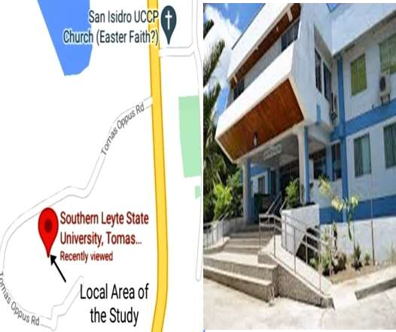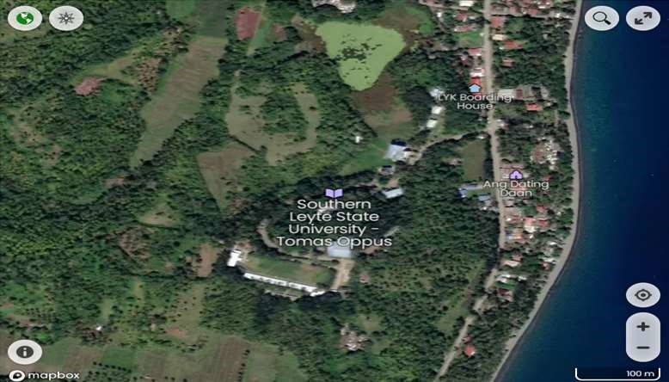

### APPENDIX C Survey Instrument DESIGN AND IMPLEMENTATION OF A WEB – BASED LIBRARY CATALOG AND MANAGEMENT SYSTEM

|  |  |  |  |  |  |  |
| --- | --- | --- | --- | --- | --- | --- |
| **PROBLEMS**  **ENCOUNTERED** | **Response (n=10)** | | |  | **Weighted Mean** | **Interpretations** |
| **4** | **3** | **2** | **1** |
| Limited availability they need to visit the library to see if the specific book is  available or not |  |  |  |  |  |  |
| Unorganized returns: If books are not properly organized upon return, it can create confusion for both students and library staff. |  |  |  |  |  |  |
| It Consumes too much time. |  |  |  |  |  |  |
| **AVERAGE** | | | |  |  |  |

**QUESTIONAIRE**

Dear Respondent:

This is a subsequent questionnaire for the capstone for the capstone project

“DESIGN AND IMPLEMENTATION OF A WEB – BASED LIBRARY CATALOG

AND MANAGEMENT SYSTEM”. This time you are going to rate the performance of the newly develop Web-Based Library Catalog System. Please fill up the space provided for each number that corresponds to your sincere and honest response.

Rest assured that all the data will be kept confidential and will only be used to serve purpose of this study.

Your cooperation and understanding will be highly appreciated.

Thank you!

**Researches**

Jadman, Janeth

Benavente, Joyce

Batiao, Janno

Abina, Grisilda S.

1. **Personal Information:** Please provide the necessary data below.

Name: ___________________

Position/Designation: ____________________

Course/Year (for student only): _________________

1. **DESIGN AND IMPLEMENTATION OF A WEB – BASED LIBRARY CATALOG AND MANAGEMENT SYSTEM.** Direction: please answer each

item by putting a check (√ ) mark on the blank provided before the choices. Use the legend as your guide.

LEGEND: **4-Strongly Agree 3-Agree 2-Disagree 1-Strongly Disagree**

|  |  |  |  |  |
| --- | --- | --- | --- | --- |
| features | 4 | 3 | 2 | 1 |
| 1. Easy user’s login. |  |  |  |  |
| 2. Provides User-Friendly interface. |  |  |  |  |
| 3. The system design is responsive. |  |  |  |  |
| 4. Effective than manual process. |  |  |  |  |
| 5. Notification / Reminder of admin is efficient and  effective. |  |  |  |  |

1. Web-Based Library Catalog System. Please examine the newly develop Development of SLSU-TO Web-Based Library Catalog System in SLSU-TO. Please answer each item by putting a check (√) mark on the blank provided before the choices. Use the legend as your guide.

LEGEND: **4-Strongly Agree 3-Agree 2-Disagree 1-Strongly Disagree**

|  |  |  |  |  |
| --- | --- | --- | --- | --- |
| FUNCTIONALITY | 4 | 3 | 2 | 1 |
| 1. The new system meets the expectation. |  |  |  |  |
| 2. Helps improve manual process. |  |  |  |  |
| 3. Less hassle in terms of manual process. |  |  |  |  |
| 4. Less time-consuming. |  |  |  |  |
|  | 4 | 3 | 2 | 1 |
| EFFECIENCY |  |  |  |  |
| 1. Easy to access the system. |  |  |  |  |
| 2. System work in the real-time. |  |  |  |  |
| 3. Hassle free and paperless |  |  |  |  |

|  |  |  |  |  |
| --- | --- | --- | --- | --- |
|  | 4 | 3 | 2 | 1 |
| DESIGN |  |  |  |  |
| 1. Fonts and style are readable. |  |  |  |  |
| 2. System flow is understandable. |  |  |  |  |
| 3. Easy to navigate. |  |  |  |  |
|  | 4 | 3 | 2 | 1 |
| SECURITY |  |  |  |  |
| 1. Strong Security of Personal Data |  |  |  |  |
| 2. Data base supported |  |  |  |  |

**Comments/Suggestions:**

**________________________________________________________________________**

**________________________________________________________________________**

**__________________________**

**_______________________________**

**Name and Signature of Respondent**

Appendix E

### SOURCE CODE

**<?php include 'navbar.php'; ?>**

**<style>**

**a.btn-get-started { background-color: #3399ff;**

**}**

**.body{ background-image:linear-gradient(rgba(0,0,0,0.4),rgba(0,0,0,0.4)), url("..//librarycatalog/images/librarryyyyyyy.jpg");**

**/* background-image:url("..//librarycatalog/images-users/librarryyyyyyy.jpg");**

**\*/ background-repeat: no-repeat; background-size:cover;**

**}**

**</style>**

**<!-- ======= Hero Section ======= -->**

**<div class="body">**

**<!-- <section id="hero" class="d-flex justify-content-center align-items-center"> -->**

**<section id="hero" class="d-flex justify-content-center align-items-center" style="background-image: url('images\librarryyyyyyy.jpg');">**

**<div class="container position-relative" data-aos="zoom-in" data-aosdelay="100">**

**<h1>Learning Today,<br>Leading Tomorrow</h1>**

**<!-- <a href="login.php" class="btn-get-started">Get Started</a> --> </div>**

**</section><!-- End Hero -->**

**</div>**

**<main id="main">**

**<!-- ======= About Section ======= -->**

**<section id="about" class="about">**

**<div class="container" data-aos="fade-up">**

**<div class="row">**

**<div class="col-lg-6 order-1 order-lg-2" data-aos="fade-left" data-aosdelay="100">**

**<img src="librarryyyyyyy.jpg" class="img-fluid" alt="">**

**</div>**

**<div class="col-lg-6 pt-4 pt-lg-0 order-2 order-lg-1 content">**

**<p class="fst-italic">**

**Libraries are a great place to find information since they have a wide variety of materials available, including book, papers, journals and much more.**

**Borrowing books is one of the key services that libraries provide.**

**Especially for people who only have mobile phones, the current method, which consists of web applications, is ineffective and not very accessible. The current system is ineffective at managing all the responsibilities a library should handle to provide better services to its users. Users of the library might have trouble locating, recognizing, choosing, and receiving the resources they required.**

**</p>**

**<!-- <ul>**

**<li><i class="bi bi-check-circle"></i> Ullamco laboris nisi ut aliquip ex ea commodo consequat.</li>**

**<li><i class="bi bi-check-circle"></i> Duis aute irure dolor in reprehenderit in voluptate velit.</li>**

**<li><i class="bi bi-check-circle"></i> Ullamco laboris nisi ut aliquip ex ea commodo consequat. Duis aute irure dolor in reprehenderit in voluptate trideta storacalaperda mastiro dolore eu fugiat nulla pariatur.</li>**

**</ul>**

**<p>**

**Ullamco laboris nisi ut aliquip ex ea commodo consequat. Duis aute irure dolor in reprehenderit in voluptate**

**</p>**

**-->**

**</div>**

**</div>**

**</div>**

**</section><!-- End About Section -->**

**<!-- ======= Counts Section ======= -->**

**<section id="counts" class="counts section-bg">**

**<div class="container">**

**<div class="row counters">**

**<div class="col-lg-3 col-6 text-center">**

**<span data-purecounter-start="0" data-purecounter-end="7000" datapurecounter-duration="1" class="purecounter" style="color: #3399ff;"></span> <p>Students</p>**

**</div>**

**<div class="col-lg-3 col-6 text-center">**

**<span data-purecounter-start="0" data-purecounter-end="4" datapurecounter-duration="1" class="purecounter" style="color: #3399ff;"></span> <p>Courses</p>**

**</div>**

**<!--**

**<div class="col-lg-3 col-6 text-center">**

**<span data-purecounter-start="0" data-purecounter-end="15" datapurecounter-duration="1" class="purecounter" style="color: #3399ff;"></span> <p>Trainers</p>**

**</div>**

**-->**

**</div>**

**</div>**

**</section><!-- End Counts Section -->**

**<!-- ======= Popular Courses Section ======= -->**

**<!--**

**<section id="books" class="courses">**

**<div class="container" data-aos="fade-up">**

**<div class="section-title">**

**<h2>Books</h2>**

**<p>Available Books</p>**

**</div>**

**<div class="row" data-aos="zoom-in" data-aos-delay="100">**

**<style>**

**.course-content h3 a.bluetext:hover {**

**color: #3399ff;**

**}**

**</style>**

**======= Trainers Section ======= -->**

**<!--**

**<section id="trainers" class="trainers">**

**<div class="container" data-aos="fade-up">**

**<div class="row" data-aos="zoom-in" data-aos-delay="100">**

**<div class="col-lg-4 col-md-6 d-flex align-items-stretch">**

**<div class="member">**

**<img src="assets/img/trainers/trainer-1.jpg" class="img-fluid" alt="">**

**<div class="member-content">**

**<h4>Walter White</h4>**

**<span>Web Development</span>**

**<p>**

**Magni qui quod omnis unde et eos fuga et exercitationem. Odio veritatis perspiciatis quaerat qui aut aut aut**

**</p>**

**<div class="social">**

**<a href=""><i class="bi bi-twitter"></i></a>**

**<a href=""><i class="bi bi-facebook"></i></a>**

**<a href=""><i class="bi bi-instagram"></i></a>**

**<a href=""><i class="bi bi-linkedin"></i></a>**

**</div>**

**</div>**

**</div>**

**</div>**

**<div class="col-lg-4 col-md-6 d-flex align-items-stretch">**

**<div class="member">**

**<img src="assets/img/trainers/trainer-2.jpg" class="img-fluid" alt="">**

**<div class="member-content">**

**<h4>Sarah Jhinson</h4>**

**<span>Marketing</span>**

**<p>**

**Repellat fugiat adipisci nemo illum nesciunt voluptas repellendus. In architecto rerum rerum temporibus**

**</p>**

**<div class="social">**

**<a href=""><i class="bi bi-twitter"></i></a>**

**<a href=""><i class="bi bi-facebook"></i></a>**

**<a href=""><i class="bi bi-instagram"></i></a>**

**<a href=""><i class="bi bi-linkedin"></i></a>**

**</div>**

**</div>**

**</div>**

**</div>**

**<div class="col-lg-4 col-md-6 d-flex align-items-stretch">**

**<div class="member">**

**<img src="assets/img/trainers/trainer-3.jpg" class="img-fluid" alt="">**

**<div class="member-content">**

**<h4>William Anderson</h4>**

**<span>Content</span>**

**<p>**

**Voluptas necessitatibus occaecati quia. Earum totam consequuntur qui porro et laborum toro des clara**

**</p>**

**<div class="social">**

**<a href=""><i class="bi bi-twitter"></i></a>**

**<a href=""><i class="bi bi-facebook"></i></a>**

**<a href=""><i class="bi bi-instagram"></i></a>**

**<a href=""><i class="bi bi-linkedin"></i></a>**

**</div>**

**</div>**

**</div>**

**</div>**

**</div>**

**</div>**

**</section>--><!-- End Trainers Section -->**

**<!-- ======= Breadcrumbs ======= -->**

**<!-- <div class="breadcrumbs" data-aos="fade-in">**

**<div class="container">**

**<h2>Contact Us</h2>**

**<p>Est dolorum ut non facere possimus quibusdam eligendi voluptatem. Quia id aut similique quia voluptas sit quaerat debitis. Rerum omnis ipsam aperiam consequatur laboriosam nemo harum praesentium. </p>**

**</div>**

**</div>**

**<section id="contact" class="contact">**

**<div class="container" data-aos="fade-up">**

**<div class="row mt-5">**

**<div class="col-lg-4">**

**<div class="info">**

**<div class="address">**

**<i class="bi bi-geo-alt"></i>**

**<h4>Location:</h4>**

**<p>Cebu Philippines</p>**

**</div>**

**<div class="email">**

**<i class="bi bi-envelope"></i>**

**<h4>Email:</h4>**

**<p>erwin@gmail.com</p>**

**</div>**

**<div class="phone">**

**<i class="bi bi-phone"></i>**

**<h4>Call:</h4>**

**<p>+639359428963</p>**

**</div>**

**</div>**

**</div>**

**<div class="col-lg-8 mt-5 mt-lg-0">**

**<form action="forms/contact.php" method="post" role="form" class="php-email-form">**

**<div class="row">**

**<div class="col-md-6 form-group">**

**<input type="text" name="name" class="form-control" id="name" placeholder="Your Name" required>**

**</div>**

**<div class="col-md-6 form-group mt-3 mt-md-0">**

**<input type="email" class="form-control" name="email" id="email" placeholder="Your Email" required>**

**</div>**

**</div>**

**<div class="form-group mt-3">**

**<input type="text" class="form-control" name="subject" id="subject" placeholder="Subject" required>**

**</div>**

**<div class="form-group mt-3">**

**<textarea class="form-control" name="message" rows="5" placeholder="Message" required></textarea>**

**</div>**

**<div class="my-3">**

**<div class="loading">Loading</div>**

**<div class="error-message"></div>**

**<div class="sent-message">Your message has been sent. Thank you!</div>**

**</div>**

**<div class="text-center"><button type="submit">Send**

**Message</button></div>**

**</form>**

**</div>**

**</div>**

**</div>**

**</section> -->**

**</main><!-- End #main -->**

**<?php include 'footer.php'; ?>**

**<?php**

**function custom_echo($x, $length)**

**{ if(strlen($x)<=$length)**

**{**

**echo $x;**

**} else**

**{**

**$y=substr($x,0,$length) . '...'; echo $y;**

**}**

**}**

**?>**

**<script> function myFunction() { var x = document.getElementById("shelf").value; document.getElementById("as_is_shelf").value = x;**

**}**

**function myFunctiontwo() { var x = document.getElementById("category").value; document.getElementById("as_is_category").value = x;**

**}**

**function myFunctionthree() { var x = document.getElementById("catalog-number").value; document.getElementById("as_is_catalog-number").value = x;**

**}**

**</script>**

**<title>Library App Catalog | Dashboard</title>**

**<?php include 'navbar.php'; ?>**

**<!-- Content Wrapper. Contains page content -->**

**<div class="content-wrapper">**

**<!-- Content Header (Page header) -->**

**<div class="content-header">**

**<div class="container-fluid">**

**<div class="row mb-2">**

**<div class="col-sm-6">**

**<h1 class="m-0">Dashboard</h1>**

**</div><!-- /.col -->**

**<div class="col-sm-6">**

**<ol class="breadcrumb float-sm-right">**

**<li class="breadcrumb-item"><a href="#">Home</a></li>**

**<li class="breadcrumb-item active">Dashboard</li>**

**</ol>**

**</div><!-- /.col -->**

**</div><!-- /.row -->**

**</div><!-- /.container-fluid -->**

**</div>**

**<!-- /.content-header -->**

**<!-- Main content -->**

**<section class="content">**

**<div class="container-fluid">**

**<!-- Small boxes (Stat box) -->**

**<div class="row d-flex justify-content-center">**

**<div class="col-lg-3 col-6">**

**<div class="small-box bg-gradient-primary">**

**<div class="inner">**

**<?php**

**$users = mysqli_query($conn, "SELECT borrowed_id from borrowed_book WHERE user_id='$id' AND borrowed_status ='Approved'");**

**$row_users = mysqli_num_rows($users);**

**?>**

**<h3><?php echo $row_users; ?></h3>**

**<p>Approved book</p>**

**</div>**

**<div class="icon">**

**<i class="fa-solid fa-book"></i>**

**</div>**

**<a href="borrowed_book.php" class="small-box-footer">More info <i class="fas fa-arrow-circle-right"></i></a>**

**</div>**

**</div>**

**<div class="col-lg-3 col-6">**

**<div class="small-box bg-gradient-warning">**

**<div class="inner">**

**<?php**

**$users = mysqli_query($conn, "SELECT borrowed_id from borrowed_book WHERE user_id='$id' AND borrowed_status ='Pending'");**

**$row_users = mysqli_num_rows($users);**

**?>**

**<h3><?php echo $row_users; ?></h3>**

**<p>Borrowed book</p>**

**</div>**

**<div class="icon">**

**<i class="fa-solid fa-book"></i>**

**</div>**

**<a href="borrowed_book.php" class="small-box-footer">More info <i class="fas fa-arrow-circle-right"></i></a>**

**</div>**

**</div>**

**<div class="col-lg-3 col-6">**

**<div class="small-box bg-gradient-success">**

**<div class="inner">**

**<?php**

**$users = mysqli_query($conn, "SELECT borrowed_id from borrowed_book WHERE user_id='$id' AND borrowed_status ='Returned'");**

**$row_users = mysqli_num_rows($users);**

**?>**

**<h3><?php echo $row_users; ?></h3>**

**<p>Returned book</p>**

**</div>**

**<div class="icon">**

**<i class="fa-solid fa-book"></i>**

**</div>**

**<a href="borrowed_book.php" class="small-box-footer">More info <i class="fas fa-arrow-circle-right"></i></a>**

**</div>**

**</div>**

**</div>**

**</div>**

**</section>**

**<!-- /.content -->**

**</div>**

**<!-- /.content-wrapper -->**

**<?php include 'footer.php'; ?> <title>Library Catalog | Administrator</title>**

**<?php include 'navbar.php'; ?>**

**<!-- Content Wrapper. Contains page content -->**

**<div class="content-wrapper">**

**<!-- Content Header (Page header) -->**

**<section class="content-header">**

**<div class="container-fluid">**

**<div class="row mb-2">**

**<div class="col-sm-6">**

**<h1>Administrator</h1>**

**</div>**

**<div class="col-sm-6">**

**<ol class="breadcrumb float-sm-right">**

**<li class="breadcrumb-item"><a href="#">Home</a></li>**

**<li class="breadcrumb-item active">Administrator</li>**

**</ol>**

**</div>**

**</div>**

**</div><!-- /.container-fluid -->**

**</section>**

**<!-- Main content -->**

**<section class="content">**

**<div class="container-fluid">**

**<div class="row">**

**<!-- /.col -->**

**<div class="col-md-12">**

**<div class="card">**

**<div class="card-header">**

**<button type="button" class="btn bg-gradient-primary" datatoggle="modal" data-target="#add_users"><i class="bi bi-plus-circle"></i>**

**Add</button>**

**</div>**

**<div class="card-body">**

**<table id="example1" class="table table-bordered table-striped">**

**<thead>**

**<tr>**

**<th>Image</th>**

**<th>Full name</th>**

**<th>Gender</th>**

**<th>Email</th>**

**<th>User type</th>**

**<th>Tools</th>**

**</tr>**

**</thead>**

**<tbody id="users_data">**

**<?php**

**$sql = mysqli_query($conn, "SELECT * FROM users WHERE user_type='Admin'");**

**while ($row = mysqli_fetch_array($sql)) {**

**?>**

**<tr>**

**<td>**

**<img src="../images-users/<?php echo $row['image']; ?>" alt="" width="35" height="35" style="margin-left: auto;margin-right: auto;display: block;border-radius: 50%;">**

**</td>**

**<td><?php echo ' '.$row['firstname'].' '.$row['middlename'].'**

**'.$row['lastname'].' '.$row['suffix'].' '; ?></td>**

**<td><?php echo $row['gender']; ?></td>**

**<td><?php echo $row['email']; ?></td>**

**<td><span class="badge bg-gradient-primary"><?php echo**

**$row['user_type']; ?></span></td>**

**<td>**

**<div class="dropdown dropleft">**

**<button class="btn btn-secondary btn-sm dropdown-toggle" type="button" id="dropdownMenuButton" data-toggle="dropdown" ariaexpanded="false"> Actions </button>**

**<div class="dropdown-menu" aria-**

**labelledby="dropdownMenuButton">**

**<button type="button" class="btn btn-primary dropdown-item" data-toggle="modal" data-target="#view<?php echo**

**$row['user_Id']; ?>">View</button>**

**<?php // if($row['user_type'] != 'Admin'): ?>**

**<button type="button" class="btn btn-primary dropdown-item" data-toggle="modal" data-target="#update<?php echo**

**$row['user_Id']; ?>">Update</button>**

**<button type="button" class="btn btn-primary dropdown-item" data-toggle="modal" data-target="#password<?php echo**

**$row['user_Id']; ?>">Change password</button>**

**<button type="button" class="btn btn-primary dropdown-item" data-toggle="modal" data-target="#delete<?php echo**

**$row['user_Id']; ?>">Delete</button>**

**<?php //endif; ?>**

**</div>**

**</div>**

**</td>**

**</tr>**

**<?php include 'admin_update_delete.php'; } ?>**

**</tbody>**

**<tfoot>**

**<tr>**

**<th>Image</th>**

**<th>Full name</th>**

**<th>Email</th>**

**<th>Address</th>**

**<th>Gender</th>**

**<th>Tools</th>**

**</tr>**

**</tfoot>**

**</table>**

**</div><!-- /.card-body -->**

**</div>**

**<!-- /.card -->**

**</div>**

**<!-- /.col --> </div>**

**<!-- /.row -->**

**</div><!-- /.container-fluid -->**

**</section>**

**<!-- /.content -->**

**</div>**

**<!-- /.content-wrapper -->**

**<?php include 'admin_add.php'; ?>**

**<?php include 'footer.php'; ?> <title>Library Catalog | Manage Book</title>**

**<?php include 'navbar.php'; ?>**

**<!-- Content Wrapper. Contains page content -->**

**<div class="content-wrapper">**

**<!-- Content Header (Page header) -->**

**<section class="content-header">**

**<div class="container-fluid">**

**<div class="row mb-2">**

**<div class="col-sm-6">**

**<h1>Manage Book</h1>**

**</div>**

**<div class="col-sm-6">**

**<ol class="breadcrumb float-sm-right">**

**<li class="breadcrumb-item"><a href="dashboard.php">Home</a></li>**

**<li class="breadcrumb-item active">Manage Book</li>**

**</ol>**

**</div>**

**</div>**

**</div><!-- /.container-fluid -->**

**</section>**

**<!-- Main content -->**

**<section class="content">**

**<div class="container-fluid">**

**<div class="row">**

**<!-- /.col -->**

**<div class="col-md-12">**

**<div class="card">**

**<div class="card-header">**

**<button type="button" class="btn bg-gradient-primary btn-sm" datatoggle="modal" data-target="#add_user"><i class="bi bi-plus-circle"></i>**

**Add</button>**

**<a href="export.php?export=managebook" class="btn btn-sm bg-success float-right mr-2"><i class="fa-solid fa-file-excel"></i> Export</a>**

**</div>**

**<div class="card-body">**

**<table class="table table-stripped table-bordered mx-0"**

**id="example111">**

**<thead class="thead-success">**

**<tr>**

**<th >Book Code</th>**

**<th>Book Title</th>**

**<th>Book Description</th>**

**<th>Book Author</th>**

**<th>Year Publish</th>**

**<th>Availability</th>**

**<th>Action</th>**

**</tr>**

**</thead>**

**<tbody>**

**<?php**

**$result = $conn->query("SELECT * FROM `book_list` ORDER BY book_name");**

**while($row = $result->fetch_assoc()){**

**?>**

**<tr>**

**<td><?php echo $row['book_code']; ?></td>**

**<td><?php echo $row['book_name']; ?></td>**

**<td><?php echo $row['book_description']; ?></td>**

**<td><?php echo $row['book_author']; ?></td>**

**<td><?php echo $row['book_publish']; ?></td>**

**<td><?php echo $row['availability']; ?></td>**

**<td>**

**<button type="button" class="btn bg-gradient-success btn-xs" data-toggle="modal" data-target="#update<?php echo**

**$row['book_id']; ?>">Update</button>**

**<button type="button" class="btn bg-gradient-danger btn-xs" data-toggle="modal" data-target="#delete<?php echo**

**$row['book_id']; ?>">Delete</button>**

**</td>**

**</tr>**

**<?php include 'books_update_delete.php'; } ?>**

**</tbody>**

**</table>**

**</div><!-- /.card-body -->**

**</div>**

**<!-- /.card -->**

**</div>**

**<!-- /.col -->**

**</div>**

**<!-- /.row -->**

**</div><!-- /.container-fluid -->**

**</section>**

**<!-- /.content -->**

**</div>**

**<!-- /.content-wrapper -->**

**<?php include 'books_add.php'; include 'footer.php'; ?>**

**GLOSSARY**

**Definition of Terms**

For better understanding of the language used in this study, the terms are conceptually and operationally defined below:

**CSS -** Cascading Style Sheets (CSS) is a simple mechanism for adding style (e.g., fonts, colors, spacing) to Web documents. These pages contain information on how to learn and use CSS and on available software. [https://www.w3.org/TR/2023/WD-css-font-loading-](https://www.w3.org/TR/2023/WD-css-font-loading-3-20230406/)

[3-20230406/](https://www.w3.org/TR/2023/WD-css-font-loading-3-20230406/)

**HTML -** HTML stands for HyperText Markup Language. It is a standard markup language for web page creation. It allows the creation and structure of sections, paragraphs, and links using HTML elements (the building blocks of a web page) such as tags and attributes.<https://www.hostinger.ph/tutorials/what-is-html>

**Hypertext Mark-up Language (HTML) -** PHP is a self-referentially acronym for PHP: Hypertext Preprocessor. Original it supposedly meant personal home page. It is an open source, server-side, HTML embedded scripting language used to create dynamic Web pages.

[https://www.memphis.edu/webdev/scripts/php.php#:~:text=PHP%20is%20a%20self%2D referentially,to%20create%20dynamic%20Web%20pages.](https://www.memphis.edu/webdev/scripts/php.php#:~:text=PHP%20is%20a%20self%2Dreferentially,to%20create%20dynamic%20Web%20pages)



**Personal Information**

Name: Janeth Jadman

Date of Birth: January 30, 2001

Place of Birth: Amparo, Macrohon, Southern Leyte

Age: 21

Civil Status: Single

Nationality: Filipino

Religion: Roman Catholic

**Educational Background:**

Elementary : Amparo Elementary School

Amparo, Macrohon, Southern Leyte

2006-2012

Juñior High School: MACI - JOSE K. DEMETERIO LEARNING FOUNDATION INC.

Sto. Rosario, Macrohon, Southern Leyte

2013-2016

Señior High School: MACI - JOSE K. DEMETERIO LEARNING FOUNDATION INC.

Sto. Rosario, Macrohon, Southern Leyte

2017-2018

Tertiary: Southern Leyte State University – Tomas Oppus

Bachelor of Science in Information Technology major in Programming

San Isidro, Tomas Oppus, Southern Leyte



**Personal Information**

Name: Joyce Benavente

Date of Birth: July 23, 1998

Place of Birth: Brgy. Timba, Malitbog Southern Leyte

Age: 24

Civil Status: Single

Nationality: Filipino

Religion: Roman Catholic

**Educational Background:**

Elementary: Sta. Cruz, Elementary School

Maujo, Malitbog Southern Leyte

2005 – 2011

Highschool: Sta. Cruz, National High school Southern Leyte

Maujo, Malitbog Southern Leyte

2011– 2014

Tertiary: Southern Leyte State University – Tomas Oppus

Bachelor of Science in Information Technology major in Programming

San Isidro, Tomas Oppus, Southern Leyte

**Personal Information**

Name: Grisilda S. Abina

Date of Birth: December 30, 2000

Place of Birth: Brgy. San Antonio, Tomas Oppus

|  |  |  |
| --- | --- | --- |
| Age: |  | 22 |
| Civil Status: |  | Single |
| Nationality: |  | Filipino |
| Religion: |  | Roman Catholic |
|  |  |  |

**Educational Background:**

Elementary : San Antonio Elementary School

San Antonio, Tomas Oppus

2006 - 2012

Highschool: Don Agustin F. Escano National Highschool

Bogo, Tomas Oppus, Southern Leyte

2018-2019

Tertiary: Southern Leyte State University – Tomas Oppus

Bachelor of Science in Information Technology major in Programming

San Isidro, Tomas Oppus, Southern Leyte



**Personal Information**

Name: Janno Batiao

Date of Birth: November 30, 2000

Place of Birth: Santo Nino, Malitbog, Southern Leyte

|  |  |  |
| --- | --- | --- |
| Age: |  | 22 |
| Civil Status: |  | Single |
| Nationality: |  | Filipino |
| Religion: |  | Roman Catholic |
|  |  |  |

**Educational Background:**

Elementary : Timba Elementary School

Brgy. Timba, Malitbog, Southern Leyte

2005 - 2011

Highschool: Santa Cruz National Highshcool

Brgy. Maujo, Malitbog, Southern Leyte

2013-2017

Tertiary: Southern Leyte State University – Tomas Oppus

Bachelor of Science in Information Technology major in Programming

San Isidro, Tomas Oppus, Southern Leyte